SOHCAHTOA (TRIGONOMETRY)
Pearson Edexcel - Thursday 4 June 2020 - Paper 2 (Calculator) Foundation Tier

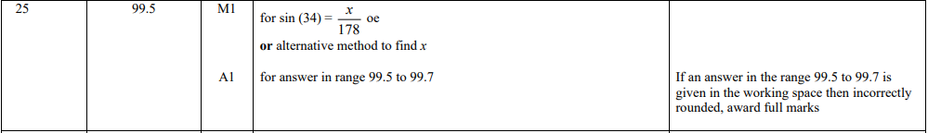

Pearson Edexcel - Thursday 6 June 2019 - Paper 2 (Calculator) Foundation Tier

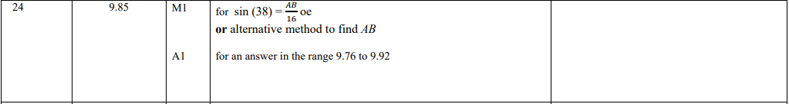

Pearson Edexcel - Monday 12 November 2018 - Paper 3 (Calculator) Foundation Tier

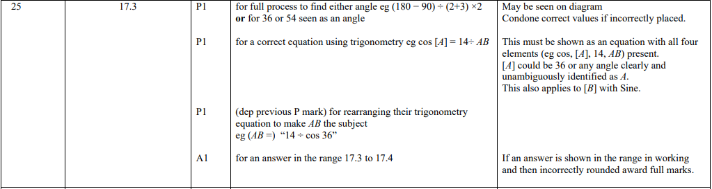

Pearson Edexcel - Tuesday 12 June 2018 - Paper 3 (Calculator) Foundation Tier

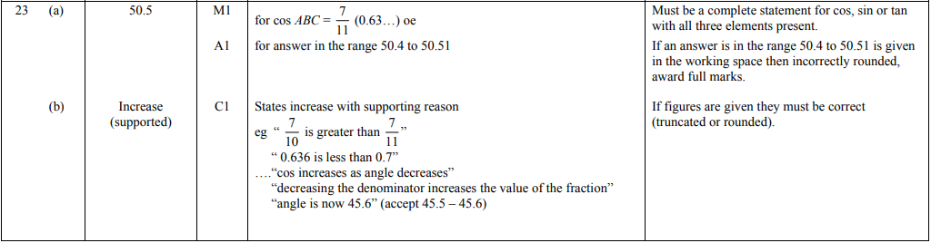
Pearson Edexcel - Monday 6 November 2017 - Paper 2 (Calculator) Foundation Tier

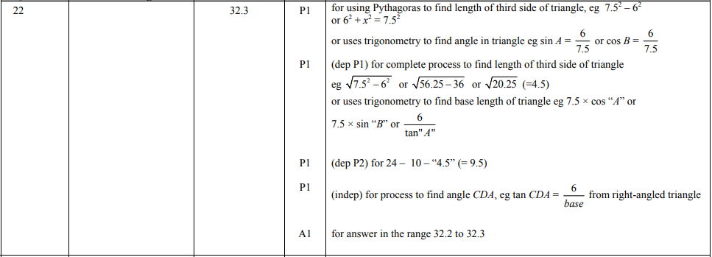

Pearson Edexcel – Specimen 1 - Paper 1 (Non-Calculator) Foundation Tier

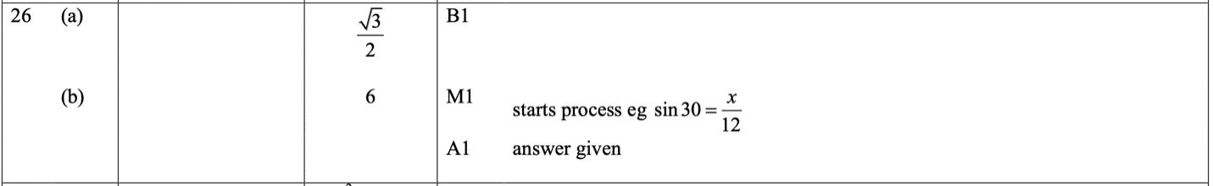
OCR November 09 November 2020- Morning (Calculator) Foundation Tier
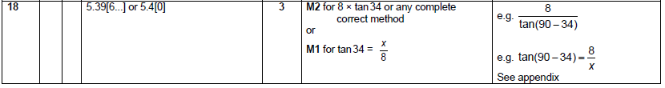

OCR Tuesday 5 November 2019 – Morning (Calculator) Foundation Tier
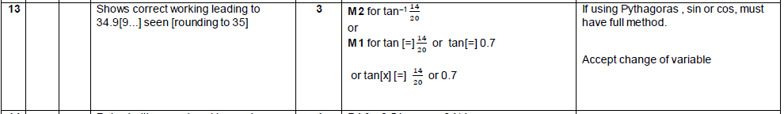

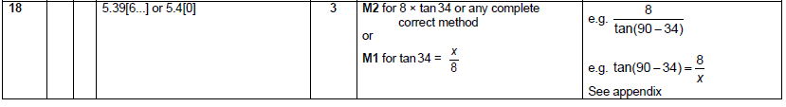

OCR Thursday 07 November 2019- Morning (Non-Calculator) Foundation Tier
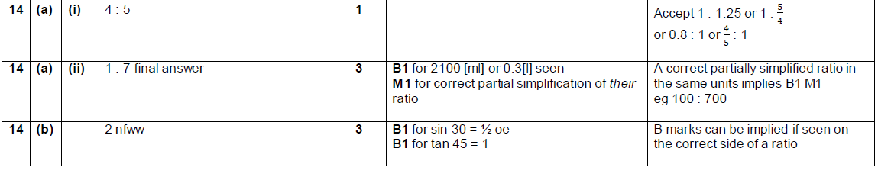

OCR Tuesday 21 May 2019 – Morning (Calculator) Foundation Tier
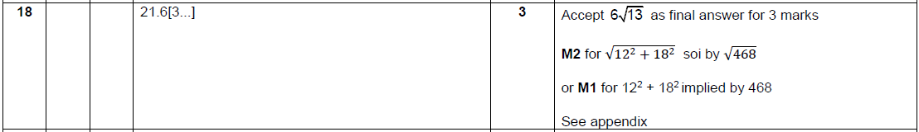

OCR Tuesday 11 June 2019 – Morning (Calculator) Foundation Tier
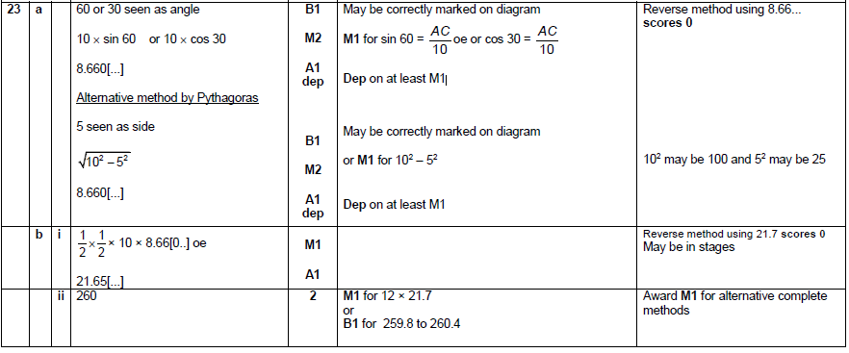

OCR Monday 12 November 2018 – Morning (Calculator) Foundation Tier
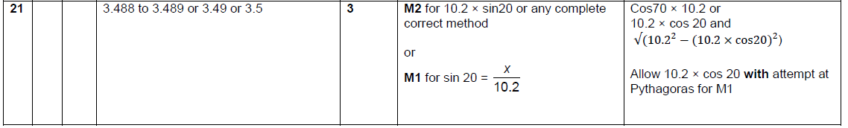

OCR Thursday 2 November 2017– Morning (Calculator) Foundation Tier
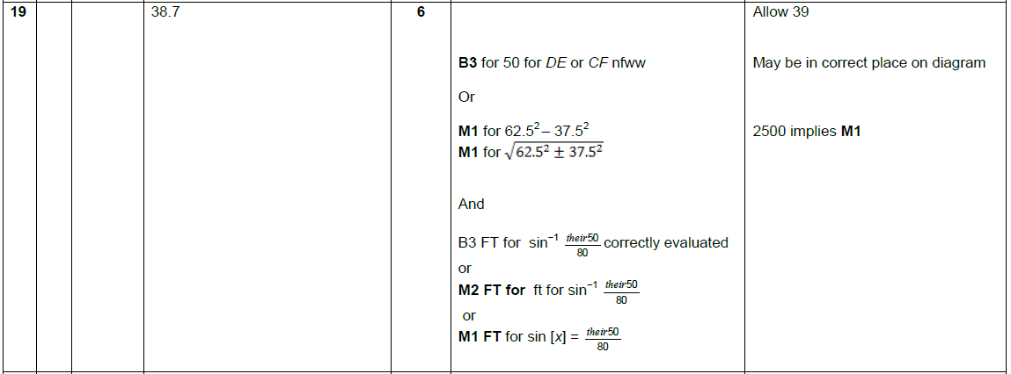

OCR Monday 6 November 2017– Morning (Calculator) Foundation Tier

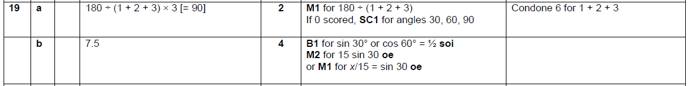

Pearson Edexcel –Sample Papers - Paper 2 (Calculator) Foundation Tier

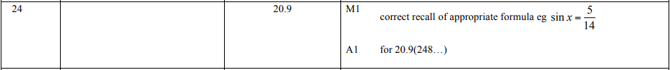
OCR Sample Question Paper 1 – Morning/Afternoon (Calculator) Foundation Tier

AQA Tuesday 19 May 2020 – Morning (Non-Calculator) Foundation Tier

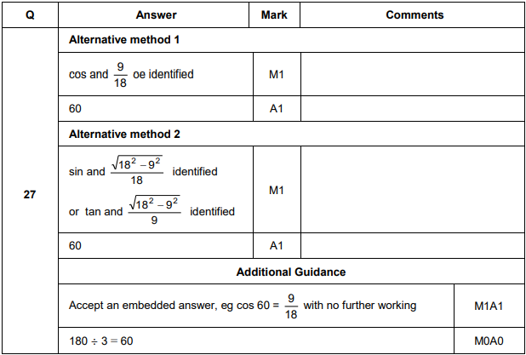

AQA Thursday 11 June 2019 – Morning (Calculator) Foundation Tier

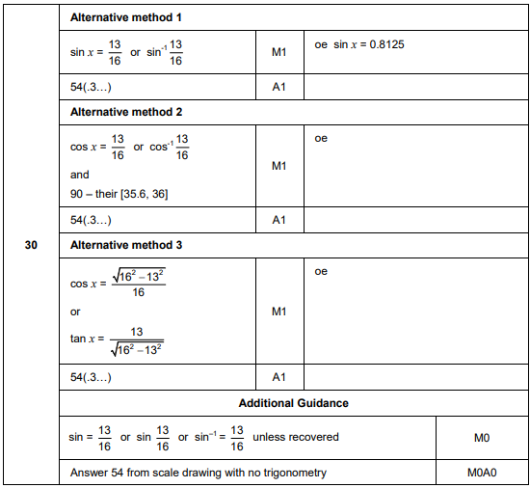
AQA Tuesday 6 November 2018 – Morning (Non-Calculator) Foundation Tier

AQA Monday 12 November 2018 – Morning (Calculator) Foundation Tier

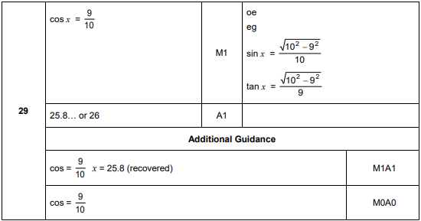
AQA Monday 6 November 2017 – Morning (Calculator) Foundation Tier

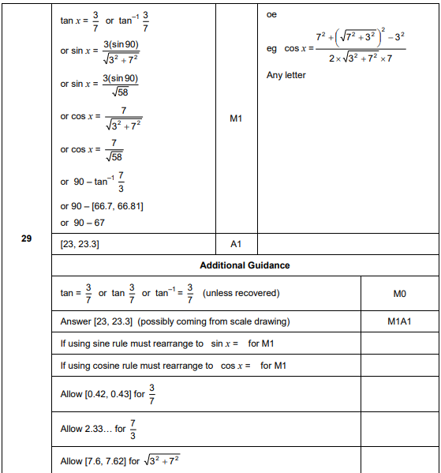

AQA Thursday 25 May 2017– Morning (Non-Calculator) Foundation Tier

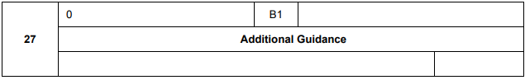
AQA Thursday 8 June 2017– Morning (Calculator) Foundation Tier

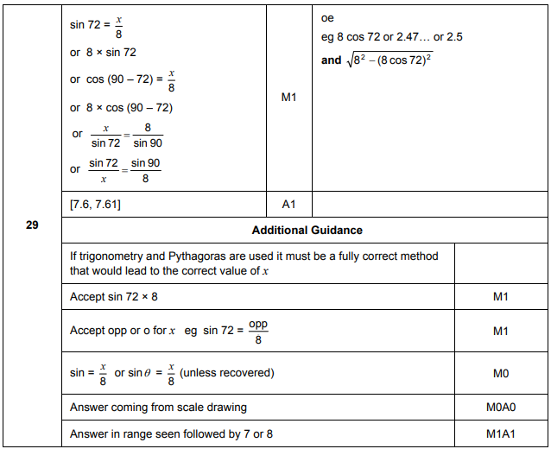

AQA Sample Paper 1– Morning (Non-Calculator) Foundation Tier

